**Experiment 1: Image Enhancement techniques**

# Program to mount the drive

from google.colab import drive

drive.mount('/content/drive')

Mounted at /content/drive

# Program to read and display color and gray scale image

import cv2

import numpy as np

from google.colab.patches import cv2_imshow

im=cv2.imread('/content/Lena.jfif')

#im=cv2.imread('/content/drive/MyDrive/im_files/rosepic12.jpg')

#new_image = np.copy(im)

gray_img = cv2.cvtColor(im, cv2.COLOR_RGB2GRAY)

print(im.shape)

cv2_imshow(im)

print(im.shape)

cv2_imshow(gray_img)

print(gray_img.shape)

im1=np.copy(gray_img)

(225, 225)

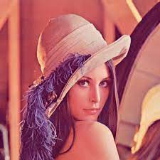

(225, 225, 3)

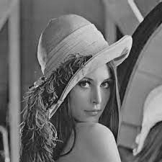

# Program to display image negative of given image

im2=255-im1

cv2_imshow(im2)

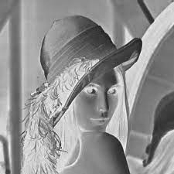

#Program for gray level slicing with background

im11=np.zeros((im1.shape[0],im1.shape[1]),np.uint8)

m,n = im1.shape

min=132

max=180

for i in range(m):

for j in range(n):

if im1[i,j] >min and im1[i,j]<max:

im11[i,j]= 255

else:

im11[i,j] = im1[i,j]

cv2_imshow(im11)

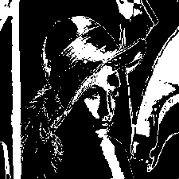

#Program for gray level slicing without background

im11=np.zeros((im1.shape[0],im1.shape[1]),np.uint8)

m,n = im1.shape

min=132

max=180

for i in range(m):

for j in range(n):

if im1[i,j] >min and im1[i,j]<max:

im11[i,j]= 0

else:

im11[i,j] = im1[i,j]

cv2_imshow(im11)

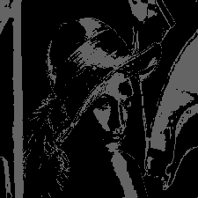

#Program for image Tresholding

T=100

for i in range(m):

for j in range(n):

if im1[i,j] < T:

im11[i,j]= 0

else:

im11[i,j] = 255

cv2_imshow(im11)

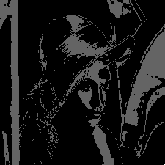

#Program for power law transformation(gamma Correction)

im12=np.zeros((im1.shape[0],im1.shape[1]),np.uint8)

im22=np.zeros((im1.shape[0],im1.shape[1]),np.uint8)

#m,n = im1.shape

gamma1=1.2

im12=np.power(im1,gamma1)

#cv2_imshow(im1)

gamma2=0.8

im22=np.power(im1,gamma2)

#cv2_imshow(im2)

hor_stack=np.row_stack((im12,im22))

cv2_imshow(hor_stack)

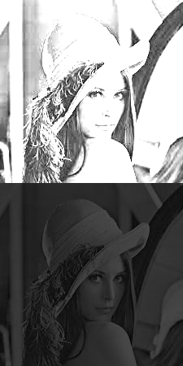

#Program for Log transformation

import math

import numpy as np

import cv2

L=255

d=np.zeros((225,225),np.uint8)

l1= math.log(L,10)

print(l1)

c=L/l1

print(c)

new=im1+1;

new1=np.log10(new)

d=c*new1

cv2_imshow(d)

2.4065401804339546

105.96124763394461

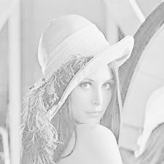

img = np.copy(im1)

lst = []

m,n = im1.shape

for i in range(m):

for j in range(n):

lst.append(np.binary_repr(img[i][j] ,width=8)) # width = no. of bits

# We have a list of strings where each string represents binary pixel value.

#To extract bit planes we need to iterate over the strings and

#store the characters corresponding to bit planes into lists.

# Multiply with 2^(n-1) and reshape to reconstruct the bit image.

eight_bit_img = (np.array([int(i[0]) for i in lst],dtype = np.uint8) * 128).reshape(img.shape[0],img.shape[1])

seven_bit_img = (np.array([int(i[1]) for i in lst],dtype = np.uint8) * 64).reshape(img.shape[0],img.shape[1])

six_bit_img = (np.array([int(i[2]) for i in lst],dtype = np.uint8) * 32).reshape(img.shape[0],img.shape[1])

five_bit_img = (np.array([int(i[3]) for i in lst],dtype = np.uint8) * 16).reshape(img.shape[0],img.shape[1])

four_bit_img = (np.array([int(i[4]) for i in lst],dtype = np.uint8) * 8).reshape(img.shape[0],img.shape[1])

three_bit_img = (np.array([int(i[5]) for i in lst],dtype = np.uint8) * 4).reshape(img.shape[0],img.shape[1])

two_bit_img = (np.array([int(i[6]) for i in lst],dtype = np.uint8) * 2).reshape(img.shape[0],img.shape[1])

one_bit_img = (np.array([int(i[7]) for i in lst],dtype = np.uint8) * 1).reshape(img.shape[0],img.shape[1])

#Concatenate these images for ease of display using cv2.hconcat()

finalr = cv2.hconcat([eight_bit_img,seven_bit_img,six_bit_img,five_bit_img])

finalv =cv2.hconcat([four_bit_img,three_bit_img,two_bit_img,one_bit_img])

# Vertically concatenate

final = cv2.vconcat([finalr,finalv])

# Display the images

cv2_imshow(final)

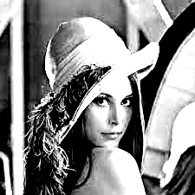

img = np.copy(im1)

lst = []

m,n = im1.shape

for i in range(m):

for j in range(n):

lst.append(np.binary_repr(img[i][j] ,width=8)) # width = no. of bits

# We have a list of strings where each string represents binary pixel value.

#To extract bit planes we need to iterate over the strings and

#store the characters corresponding to bit planes into lists.

# Multiply with 2^(n-1) and reshape to reconstruct the bit image.

eight_bit_img = (np.array([int(i[0]) for i in lst],dtype = np.uint8) * 128).reshape(img.shape[0],img.shape[1])

seven_bit_img = (np.array([int(i[1]) for i in lst],dtype = np.uint8) * 64).reshape(img.shape[0],img.shape[1])

six_bit_img = (np.array([int(i[2]) for i in lst],dtype = np.uint8) * 32).reshape(img.shape[0],img.shape[1])

five_bit_img = (np.array([int(i[3]) for i in lst],dtype = np.uint8) * 16).reshape(img.shape[0],img.shape[1])

four_bit_img = (np.array([int(i[4]) for i in lst],dtype = np.uint8) * 8).reshape(img.shape[0],img.shape[1])

three_bit_img = (np.array([int(i[5]) for i in lst],dtype = np.uint8) * 4).reshape(img.shape[0],img.shape[1])

two_bit_img = (np.array([int(i[6]) for i in lst],dtype = np.uint8) * 2).reshape(img.shape[0],img.shape[1])

one_bit_img = (np.array([int(i[7]) for i in lst],dtype = np.uint8) * 1).reshape(img.shape[0],img.shape[1])

#Concatenate these images for ease of display using cv2.hconcat()

finalr = cv2.hconcat([eight_bit_img,seven_bit_img,six_bit_img,five_bit_img])

finalv =cv2.hconcat([four_bit_img,three_bit_img,two_bit_img,one_bit_img])

# Vertically concatenate

final = cv2.vconcat([finalr,finalv])

# Display the images

cv2_imshow(final)

**Experiment 2: Histogram Equalization**

import cv2

import numpy as np

from google.colab.patches import cv2_imshow

from matplotlib import pyplot as plt

im=np.zeros((200,200),np.uint8)

cv2.rectangle(im,(0,100),(200,200),(255),-1)

cv2.rectangle(im,(0,50),(100,100),(127),-1)

cv2_imshow(im)

plt.hist(im.ravel(),256,[0,256])

plt.show()



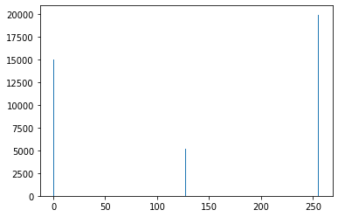

import cv2

import numpy as np

from google.colab.patches import cv2_imshow

from matplotlib import pyplot as plt

im=cv2.imread('/content/Lena.jfif')

cv2_imshow(im)

plt.hist(im.ravel(),256,[0,256])

plt.show()



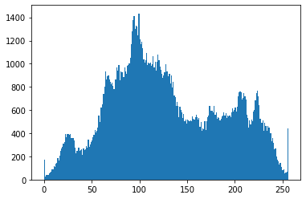

import cv2

import numpy as np

from google.colab.patches import cv2_imshow

from matplotlib import pyplot as plt

im=cv2.imread('/content/Lena.jfif')

b,g,r=cv2.split(im)

cv2_imshow(im)

cv2_imshow(b)

cv2_imshow(g)

cv2_imshow(r)

plt.hist(im.ravel(),256,[0,256])

plt.hist(b.ravel(),256,[0,256])

plt.hist(g.ravel(),256,[0,256])

plt.hist(r.ravel(),256,[0,256])

plt.show()



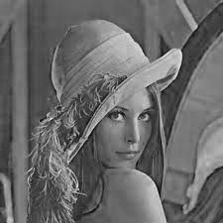

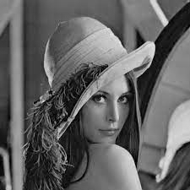

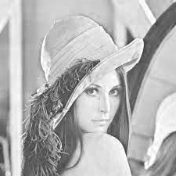

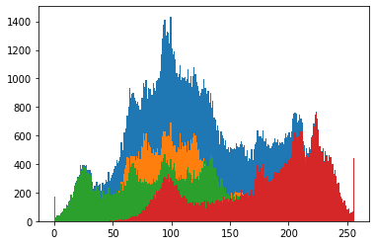

import cv2

import numpy as np

from matplotlib import pyplot as plt

from google.colab.patches import cv2_imshow

#path = "/content/drive/MyDrive/content/lena.jpg"

img = cv2.imread('/content/Lena.jfif',0)

cv2_imshow(img)

equ=np.zeros((img.shape[1],img.shape[0]),np.uint8)

equ = cv2.equalizeHist(img)

cv2_imshow(equ)

hist,bins = np.histogram(img.flatten(),256,[0,256])

cdf = hist.cumsum()

cdf_normalized = cdf * float(hist.max()) / cdf.max()

plt.plot(cdf_normalized, color = 'b')

plt.hist(img.flatten(),256,[0,256], color = 'r')

plt.xlim([0,256])

plt.legend(('cdf','histogram'), loc = 'upper left')

plt.show()

hist_1,bins_1 = np.histogram(equ.flatten(),256,[0,256])

cdf_1 = hist_1.cumsum()

#print (cdf)

cdf_normalized_1 = cdf_1 * float(hist_1.max()) / cdf_1.max()

#print(cdf_normalized)

plt.plot(cdf_normalized_1, color = 'b')

plt.hist(equ.flatten(),256,[0,256], color = 'r')

plt.xlim([0,256])

plt.legend(('cdf','histogram'), loc = 'upper left')

plt.show()

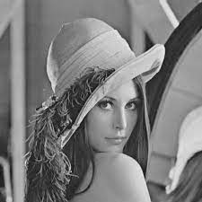

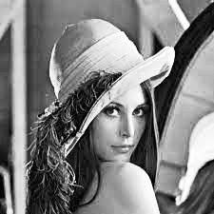

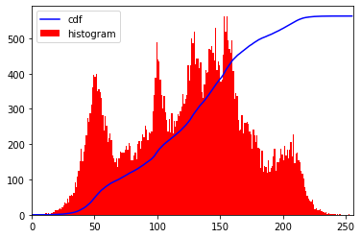

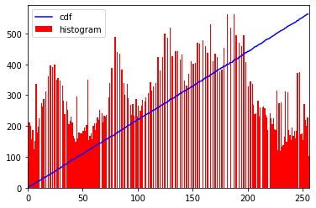

# import Opencv

import cv2

# import Numpy

import numpy as np

# read a image using imread

img = cv2.imread('/content/Lena.jfif', 0)

# creating a Histograms Equalization

# of a image using cv2.equalizeHist()

equ = cv2.equalizeHist(img)

# stacking images side-by-side

res = np.hstack((img, equ))

# show image input vs output

cv2_imshow(res)

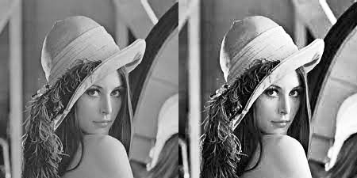

**Experiment 3:Spatial domain low pass and high pass filters**

**#Program for implementing Prewitt Filter**

**import cv2**

**import numpy as np**

**from google.colab.patches import cv2_imshow**

**im=cv2.imread('/content/Lena.jfif',0)**

**p_x=np.array([[1,1,1],[0,0,0],[-1,-1,-1]])**

**p_y=np.array([[1,0,-1],[1,0,-1],[1,0,-1]])**

**pre_im_x=cv2.filter2D(im,-1,p_x)**

**pre_im_y=cv2.filter2D(im,-1,p_y)**

**#cv2_imshow(pre_im_x)**

**#cv2_imshow(pre_im_y)**

**#cv2_imshow(pre_im_x+pre_im_y)**

**hor_stack=np.column_stack((pre_im_x,pre_im_y,pre_im_x+pre_im_y ))**

**cv2_imshow(hor_stack)**

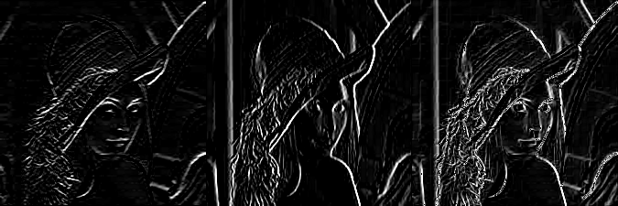

**#Program for implementing Sobel Filter**

**import cv2**

**import numpy as np**

**from google.colab.patches import cv2_imshow**

**im=cv2.imread('/content/Lena.jfif',0)**

**p_x=np.array([[1, 2,1],[0,0,0],[-1,-2,-1]])**

**p_y=np.array([[1,0,-1],[2,0,-2],[1,0,-1]])**

**pre_im_x=cv2.filter2D(im,-1,p_x)**

**pre_im_y=cv2.filter2D(im,-1,p_y)**

**#cv2_imshow(pre_im_x)**

**#cv2_imshow(pre_im_y)**

**#cv2_imshow(pre_im_x+pre_im_y)**

**hor_stack=np.column_stack((pre_im_x,pre_im_y,pre_im_x+pre_im_y ))**

**cv2_imshow(hor_stack)**

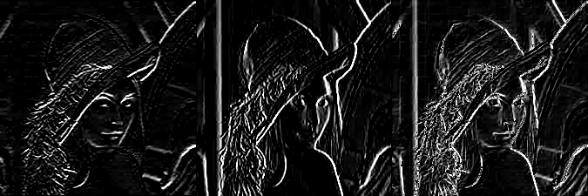

**##Program for implementing Laplacian Filter**

**import cv2**

**import numpy as np**

**from google.colab.patches import cv2_imshow**

**im=cv2.imread('/content/Lena.jfif',0)**

**p_x=np.array([[-1,-1,-1],[-1,8,-1],[-1,-1,-1]])**

**#p_y=np.array([[1,0,-1],[1,0,-1],[1,0,-1]])**

**pre_im_x=cv2.filter2D(im,-1,p_x)**

**pre_im_y=cv2.filter2D(im,-1,p_y)**

**cv2_imshow(pre_im_x)**

**#cv2_imshow(pre_im_y)**

**#cv2_imshow(pre_im_x+pre_im_y)**

**#hor_stack=np.column_stack((pre_im_x,pre_im_y,pre_im_x+pre_im_y ))**

**#cv2_imshow(hor_stack)**

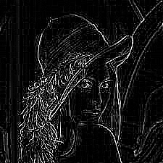

**#Program for implementing Averaging & Weighted averaging Filter**

**import cv2**

**import numpy as np**

**from google.colab.patches import cv2_imshow**

**im=cv2.imread('/content/Lena.jfif',0)**

**print(im.shape)**

**p_x=np.array([[1,1,1],[1,1,1],[1,1,1]])**

**pre_im_x=1/9*p_x**

**p_y=np.array([[1,2,1],[2,4,2],[1,2,1]])**

**pre_im_x1=cv2.filter2D(im,-1,pre_im_x)**

**pre_im_y=1/16*p_y**

**pre_im_y1=cv2.filter2D(im,-1,pre_im_y)**

**cv2_imshow(pre_im_y1)**

**cv2_imshow(pre_im_y1)**

**hor_stack=np.column_stack((pre_im_x1,pre_im_y1 ))**

**cv2_imshow(hor_stack)**

**(225, 225)**

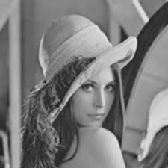



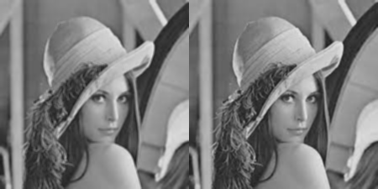

**##Program for enhancement of image implementing Laplacian Filter**

**import cv2**

**import numpy as np**

**from google.colab.patches import cv2_imshow**

**im=cv2.imread('/content/Lena.jfif',0)**

**p_x=np.array([[-1,-1,-1],[-1,9,-1],[-1,-1,-1]])**

**p_y=np.array([[0,-1, 0],[-1, 5,-1],[0,-1, 0]])**

**pre_im_x=cv2.filter2D(im,-1,p_x)**

**pre_im_y=cv2.filter2D(im,-1,p_y)**

**cv2_imshow(pre_im_x)**

**cv2_imshow(pre_im_y)**

**hor_stack=np.column_stack((pre_im_x,pre_im_y ))**

**cv2_imshow(hor_stack)**

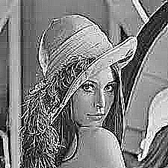

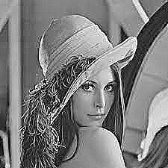

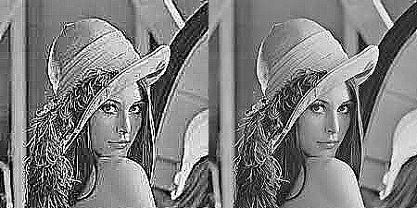

**Experiment 4: Image Morphing**

**# Display the given color and grayscale image**

**import cv2**

**from google.colab.patches import cv2_imshow**

**import numpy as np**

**import matplotlib.pyplot as plt**

**im=cv2.imread('/content/Lenna_(test_image) (1).png')**

**lane_image = np.copy(im)**

**gray = cv2.cvtColor(lane_image, cv2.COLOR_RGB2GRAY)**

**cv2_imshow(im)**

**cv2_imshow(gray)**

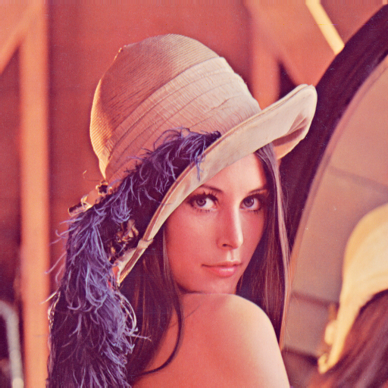

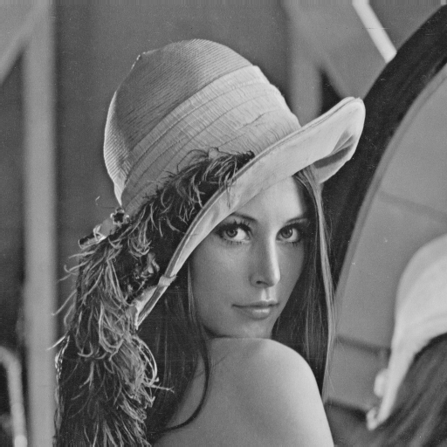

**# output image obtained after canny edge detection**

**canny_img=cv2.Canny(gray,150,200)**

**cv2_imshow(canny_img)**

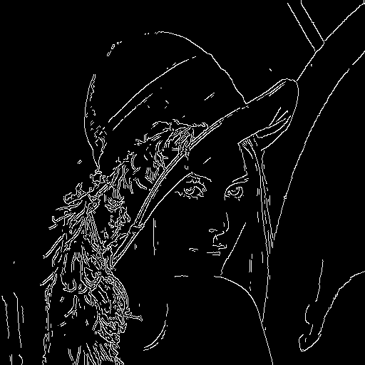

**# Output image after dilation**

**kernel=np.ones((3,3),np.uint8)**

**dilate_img=cv2.dilate(canny_img, kernel, iterations=1 )**

**print(kernel)**

**cv2_imshow(dilate_img)**

**[[1 1 1]**

**[1 1 1]**

**[1 1 1]]**

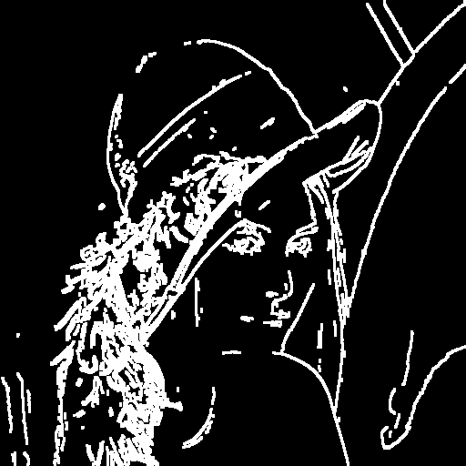

**# Output image after erosion**

**kernel=np.ones((3,3),np.uint8)**

**erode_img=cv2.erode(dilate_img, kernel, iterations=1 )**

**print(kernel)**

**cv2_imshow(erode_img)**

**[[1 1 1]**

**[1 1 1]**

**[1 1 1]]**

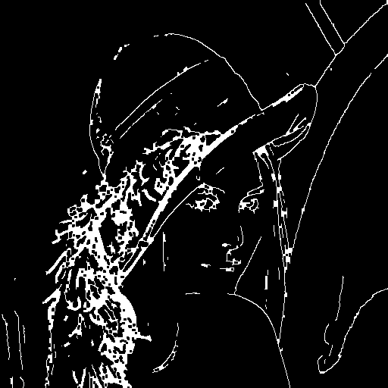

**# Output image after opening**

**open_img=cv2.dilate(erode_img,kernel,iterations=1)**

**cv2_imshow(open_img)**



**# Output image after closing**

**close_img=cv2.erode(dilate_img,kernel,iterations=1)**

**cv2_imshow(close_img)**

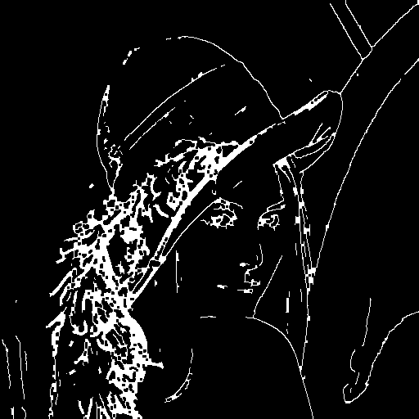

**# Output image after boudary extraction**

**boundary_img= canny_img - erode_img**

**boundary_img=boundary_img*255**

**cv2_imshow(boundary_img)**

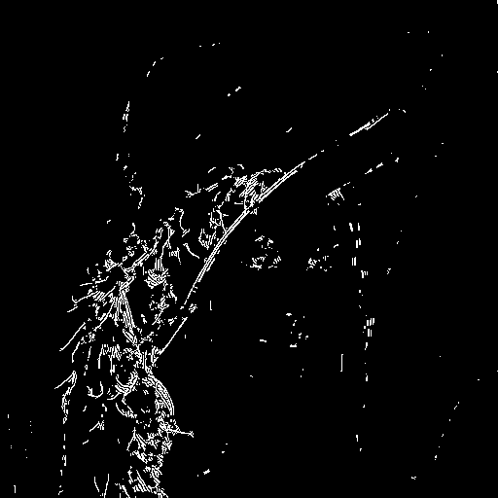

**Experiment 5:Canny Edge Detection**

**#Program to run canny edge detector on a given image to find out the edges**

**import numpy as np**

**import os**

**import cv2**

**import matplotlib.pyplot as plt**

**from google.colab.patches import cv2_imshow**

**# defining the canny detector function**

**# here weak_th and strong_th are thresholds for**

**# double thresholding step**

**def Canny_detector(img, weak_th = None, strong_th = None):**

**# conversion of image to grayscale**

**img = cv2.cvtColor(img, cv2.COLOR_BGR2GRAY)**

**# Noise reduction step**

**img = cv2.GaussianBlur(img, (5, 5), 1.4)**

**# Calculating the gradients**

**gx = cv2.Sobel(np.float32(img), cv2.CV_64F, 1, 0, 3)**

**gy = cv2.Sobel(np.float32(img), cv2.CV_64F, 0, 1, 3)**

**# Conversion of Cartesian coordinates to polar**

**mag, ang = cv2.cartToPolar(gx, gy, angleInDegrees = True)**

**# setting the minimum and maximum thresholds**

**# for double thresholding**

**mag_max = np.max(mag)**

**if not weak_th:weak_th = mag_max * 0.1**

**if not strong_th:strong_th = mag_max * 0.5**

**# getting the dimensions of the input image**

**height, width = img.shape**

**# Looping through every pixel of the grayscale**

**# image**

**for i_x in range(width):**

**for i_y in range(height):**

**grad_ang = ang[i_y, i_x]**

**grad_ang = abs(grad_ang-180) if abs(grad_ang)>180 else abs(grad_ang)**

**# selecting the neighbours of the target pixel**

**# according to the gradient direction**

**# In the x axis direction**

**if grad_ang<= 22.5:**

**neighb_1_x, neighb_1_y = i_x-1, i_y**

**neighb_2_x, neighb_2_y = i_x + 1, i_y**

**# top right (diagonal-1) direction**

**elif grad_ang>22.5 and grad_ang<=(22.5 + 45):**

**neighb_1_x, neighb_1_y = i_x-1, i_y-1**

**neighb_2_x, neighb_2_y = i_x + 1, i_y + 1**

**# In y-axis direction**

**elif grad_ang>(22.5 + 45) and grad_ang<=(22.5 + 90):**

**neighb_1_x, neighb_1_y = i_x, i_y-1**

**neighb_2_x, neighb_2_y = i_x, i_y + 1**

**# top left (diagonal-2) direction**

**elif grad_ang>(22.5 + 90) and grad_ang<=(22.5 + 135):**

**neighb_1_x, neighb_1_y = i_x-1, i_y + 1**

**neighb_2_x, neighb_2_y = i_x + 1, i_y-1**

**# Now it restarts the cycle**

**elif grad_ang>(22.5 + 135) and grad_ang<=(22.5 + 180):**

**neighb_1_x, neighb_1_y = i_x-1, i_y**

**neighb_2_x, neighb_2_y = i_x + 1, i_y**

**# Non-maximum suppression step**

**if width>neighb_1_x>= 0 and height>neighb_1_y>= 0:**

**if mag[i_y, i_x]<mag[neighb_1_y, neighb_1_x]:**

**mag[i_y, i_x]= 0**

**continue**

**if width>neighb_2_x>= 0 and height>neighb_2_y>= 0:**

**if mag[i_y, i_x]<mag[neighb_2_y, neighb_2_x]:**

**mag[i_y, i_x]= 0**

**weak_ids = np.zeros_like(img)**

**strong_ids = np.zeros_like(img)**

**ids = np.zeros_like(img)**

**# double thresholding step**

**for i_x in range(width):**

**for i_y in range(height):**

**grad_mag = mag[i_y, i_x]**

**if grad_mag<weak_th:**

**mag[i_y, i_x]= 0**

**elif strong_th>grad_mag>= weak_th:**

**ids[i_y, i_x]= 1**

**else:**

**ids[i_y, i_x]= 2**

**# finally returning the magnitude of**

**# gradients of edges**

**return mag**

**frame = cv2.imread('/content/Lenna_(test_image) (1).png')**

**# calling the designed function for**

**# finding edges**

**canny_img = Canny_detector(frame)**

**# Displaying the input and output image**

**#plt.figure()**

**#f, plots = plt.subplots(2, 1)**

**#plots[0].imshow(frame)**

**#plots[1].imshow(canny_img)**

**cv2_imshow(frame)**

**cv2_imshow(canny_img)**

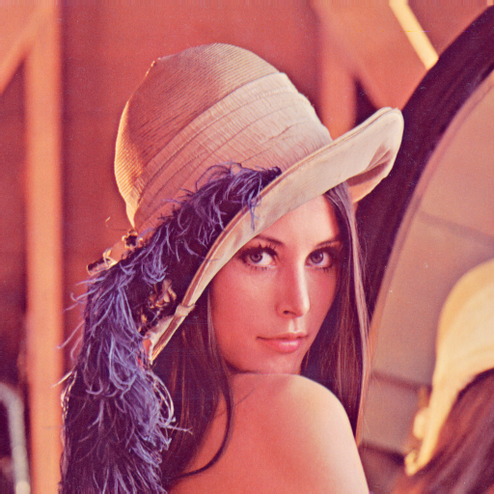

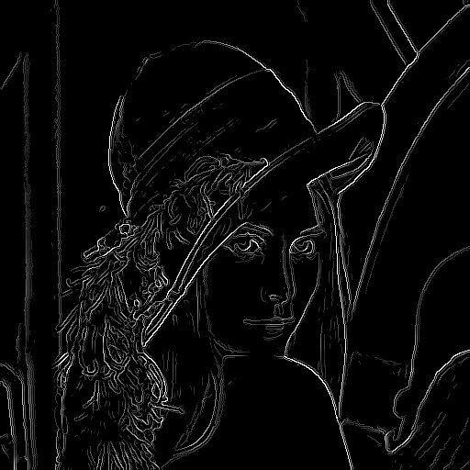

**Experiment 6:Fourier Spectrum of given image**

**#Program to plot the fourier spectrum of given image**

**import cv2**

**import numpy as np**

**from matplotlib import pyplot as plt**

**from google.colab.patches import cv2_imshow**

**image = cv2.imread('/content/Lena img.jpg',0)**

**f = np.fft.fft2(image)**

**fshift = np.fft.fftshift(f)**

**magnitude_spectrum = 20*np.log(np.abs(fshift))**

**plt.subplot(121),plt.imshow(image, cmap = 'gray')**

**plt.title('Input Image'), plt.xticks([]), plt.yticks([])**

**plt.subplot(122),plt.imshow(magnitude_spectrum, cmap = 'gray')**

**plt.title('Magnitude Spectrum'), plt.xticks([]), plt.yticks([])**

**plt.show()**

**#program to apply the ideal Low pass and High pass filters on the given image**

**image = cv2.resize(image,(200,200))**

**rows, cols = image.shape**

**crow,ccol = rows/2 , cols/2**

**print (image.shape)**

**dft=cv2.dft(np.float32(image),flags=cv2.DFT_COMPLEX_OUTPUT)**

**dft_shift=np.fft.fftshift(dft)**

**magnitude_spectrum=20*np.log(cv2.magnitude(dft_shift[:,:,0],dft_shift[:,:,1]))**

**print(crow)**

**print(ccol)**

**r=80**

**mask = np.zeros((rows, cols,2), dtype=np.float32)**

**mask1 = np.ones((rows, cols,2), dtype=np.float32)**

**center=[crow,ccol]**

**x,y=np.ogrid[:rows,:cols]**

**mask_area=(x-center[0])**2+(y-center[1])**2<=r*r**

**mask[mask_area]=1**

**mask1[mask_area]=0;**

**fshift = dft_shift * mask**

**fshift1=dft_shift*mask1**

**fshift_mask_mag=20*np.log(cv2.magnitude(fshift[:,:,0],fshift[:,:,1]))**

**f_shift=np.fft.ifftshift(fshift)**

**img_back=cv2.idft(f_shift)**

**img_back=cv2.magnitude(img_back[:,:,0],img_back[:,:,1])**

**fshift_mask_mag1=20*np.log(cv2.magnitude(fshift1[:,:,0],fshift1[:,:,1]))**

**f_shift1=np.fft.ifftshift(fshift1)**

**img_back1=cv2.idft(f_shift1)**

**img_back1=cv2.magnitude(img_back1[:,:,0],img_back1[:,:,1])**

**plt.subplot(441),plt.imshow(image, cmap = 'gray')**

**plt.title('Input Image'), plt.xticks([]), plt.yticks([])**

**plt.subplot(442),plt.imshow(magnitude_spectrum, cmap = 'gray')**

**plt.title('Image after HPF'), plt.xticks([]), plt.yticks([])**

**plt.subplot(443),plt.imshow(fshift_mask_mag, cmap = 'gray')**

**plt.title('Result after filtering'), plt.xticks([]), plt.yticks([])**

**plt.subplot(444),plt.imshow(img_back, cmap = 'gray')**

**plt.subplot(445),plt.imshow(image, cmap = 'gray')**

**plt.title('Input Image'), plt.xticks([]), plt.yticks([])**

**plt.subplot(446),plt.imshow(magnitude_spectrum, cmap = 'gray')**

**plt.title('Image after LPF'), plt.xticks([]), plt.yticks([])**

**plt.subplot(447),plt.imshow(fshift_mask_mag1, cmap = 'gray')**

**plt.title('Result after filtering'), plt.xticks([]), plt.yticks([])**

**plt.subplot(448),plt.imshow(img_back1, cmap = 'gray')**

**#program to apply Butterworth Low pass filter on the given image**

**image = cv2.resize(image,(200,200))**

**rows, cols = image.shape**

**crow,ccol = rows/2 , cols/2**

**print (image.shape)**

**dft=cv2.dft(np.float32(image),flags=cv2.DFT_COMPLEX_OUTPUT)**

**dft_shift=np.fft.fftshift(dft)**

**magnitude_spectrum=20*np.log(cv2.magnitude(dft_shift[:,:,0],dft_shift[:,:,1]))**

**print(crow)**

**print(ccol)**

**r=40**

**hh_mask = np.zeros((rows, cols,2), dtype=np.float32)**

**center=[crow,ccol]**

**x,y=np.ogrid[:rows,:cols]**

**for i in range(image.shape[0]):**

**for j in range(image.shape[1]):**

**mask_area=(i-center[0])**2+(j-center[1])**2**

**a=mask_area/r**

**a1=pow(a,2)**

**hh_mask[i,j] =1/(1+a1)**

**fshift = dft_shift * hh_mask**

**fshift_mask_mag=20*np.log(cv2.magnitude(fshift[:,:,0],fshift[:,:,1]))**

**f_shift=np.fft.ifftshift(fshift)**

**img_back=cv2.idft(f_shift)**

**img_back=cv2.magnitude(img_back[:,:,0],img_back[:,:,1])**

**hh_mask1=1-hh_mask**

**plt.subplot(221),plt.imshow(image, cmap = 'gray')**

**plt.title('Input Image'), plt.xticks([]), plt.yticks([])**

**plt.subplot(222),plt.imshow(magnitude_spectrum, cmap = 'gray')**

**plt.title('Image after LPF'), plt.xticks([]), plt.yticks([])**

**plt.subplot(223),plt.imshow(fshift_mask_mag, cmap = 'gray')**

**plt.title('Result after filtering'), plt.xticks([]), plt.yticks([])**

**plt.subplot(224),plt.imshow(img_back, cmap = 'gray')**

**#program to apply Butterworth High pass filters on the given image**

**fshift1 = dft_shift * hh_mask1**

**fshift_mask_mag1=20*np.log(cv2.magnitude(fshift1[:,:,0],fshift1[:,:,1]))**

**f_shift1=np.fft.ifftshift(fshift1)**

**img_back1=cv2.idft(f_shift1)**

**img_back1=cv2.magnitude(img_back1[:,:,0],img_back1[:,:,1])**

**hh_mask1=1-hh_mask**

**plt.subplot(221),plt.imshow(image, cmap = 'gray')**

**plt.title('Input Image'), plt.xticks([]), plt.yticks([])**

**plt.subplot(222),plt.imshow(magnitude_spectrum, cmap = 'gray')**

**plt.title('Image after HPF'), plt.xticks([]), plt.yticks([])**

**plt.subplot(223),plt.imshow(fshift_mask_mag1, cmap = 'gray')**

**plt.title('Result after filtering'), plt.xticks([]), plt.yticks([])**

**plt.subplot(224),plt.imshow(img_back1, cmap = 'gray')**

**#program to apply Gaussian Low pass filter on the given image**

**import math**

**image = cv2.resize(image,(200,200))**

**rows, cols = image.shape**

**crow,ccol = rows/2 , cols/2**

**print (image.shape)**

**dft=cv2.dft(np.float32(image),flags=cv2.DFT_COMPLEX_OUTPUT)**

**dft_shift=np.fft.fftshift(dft)**

**magnitude_spectrum=20*np.log(cv2.magnitude(dft_shift[:,:,0],dft_shift[:,:,1]))**

**print(crow)**

**print(ccol)**

**r=60**

**gg_mask = np.zeros((rows, cols,2), dtype=np.float32)**

**gg_mask1 = np.zeros((rows, cols,2), dtype=np.float32)**

**center=[crow,ccol]**

**x,y=np.ogrid[:rows,:cols]**

**for i in range(image.shape[0]):**

**for j in range(image.shape[1]):**

**mask_area=(i-center[0])**2+(j-center[1])**2**

**a=2*r*r**

**a2=mask_area/a;**

**a1=math.exp(a2)**

**gg_mask[i,j] =a1**

**fshift_g = dft_shift * gg_mask**

**fshift_mask_mag_g=20*np.log(cv2.magnitude(fshift_g[:,:,0],fshift_g[:,:,1]))**

**f_shift_g=np.fft.ifftshift(fshift_g)**

**img_back_g=cv2.idft(f_shift_g)**

**img_back_g=cv2.magnitude(img_back_g[:,:,0],img_back_g[:,:,1])**

**plt.subplot(221),plt.imshow(image, cmap = 'gray')**

**plt.title('Input Image'), plt.xticks([]), plt.yticks([])**

**plt.subplot(222),plt.imshow(magnitude_spectrum, cmap = 'gray')**

**plt.title('Image after LPF'), plt.xticks([]), plt.yticks([])**

**plt.subplot(223),plt.imshow(fshift_mask_mag_g, cmap = 'gray')**

**plt.title('Result after filtering'), plt.xticks([]), plt.yticks([])**

**plt.subplot(224),plt.imshow(img_back_g, cmap = 'gray')**

**#program to apply Gaussian High pass filter on the given image**

**gg_mask1=1-gg_mask**

**fshift_g1 = dft_shift * gg_mask1**

**fshift_mask_mag_g1=20*np.log(cv2.magnitude(fshift_g1[:,:,0],fshift_g1[:,:,1]))**

**f_shift_g1=np.fft.ifftshift(fshift_g1)**

**img_back_g1=cv2.idft(f_shift_g1)**

**img_back_g1=cv2.magnitude(img_back_g1[:,:,0],img_back_g1[:,:,1])**

**plt.subplot(221),plt.imshow(image, cmap = 'gray')**

**plt.title('Input Image'), plt.xticks([]), plt.yticks([])**

**plt.subplot(222),plt.imshow(magnitude_spectrum, cmap = 'gray')**

**plt.title('Image after HPF'), plt.xticks([]), plt.yticks([])**

**plt.subplot(223),plt.imshow(fshift_mask_mag_g1, cmap = 'gray')**

**plt.title('Result in Filtering'), plt.xticks([]), plt.yticks([])**

**plt.subplot(224),plt.imshow(img_back_g1, cmap = 'gray')**

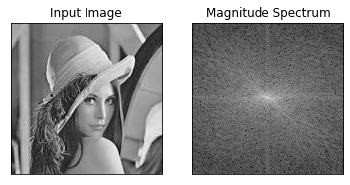

**(200, 200)**

**100.0**

**100.0**

**/usr/local/lib/python3.7/dist-packages/ipykernel_launcher.py:44: RuntimeWarning: divide by zero encountered in log**

**/usr/local/lib/python3.7/dist-packages/ipykernel_launcher.py:49: RuntimeWarning: divide by zero encountered in log**

**(200, 200)**

**100.0**

**100.0**

**(200, 200)**

**100.0**

**100.0**

**/usr/local/lib/python3.7/dist-packages/ipykernel_launcher.py:112: RuntimeWarning: divide by zero encountered in log**

**/usr/local/lib/python3.7/dist-packages/ipykernel_launcher.py:118: MatplotlibDeprecationWarning: Adding an axes using the same arguments as a previous axes currently reuses the earlier instance. In a future version, a new instance will always be created and returned. Meanwhile, this warning can be suppressed, and the future behavior ensured, by passing a unique label to each axes instance.**

**/usr/local/lib/python3.7/dist-packages/ipykernel_launcher.py:120: MatplotlibDeprecationWarning: Adding an axes using the same arguments as a previous axes currently reuses the earlier instance. In a future version, a new instance will always be created and returned. Meanwhile, this warning can be suppressed, and the future behavior ensured, by passing a unique label to each axes instance.**

**/usr/local/lib/python3.7/dist-packages/ipykernel_launcher.py:122: MatplotlibDeprecationWarning: Adding an axes using the same arguments as a previous axes currently reuses the earlier instance. In a future version, a new instance will always be created and returned. Meanwhile, this warning can be suppressed, and the future behavior ensured, by passing a unique label to each axes instance.**

**/usr/local/lib/python3.7/dist-packages/ipykernel_launcher.py:124: MatplotlibDeprecationWarning: Adding an axes using the same arguments as a previous axes currently reuses the earlier instance. In a future version, a new instance will always be created and returned. Meanwhile, this warning can be suppressed, and the future behavior ensured, by passing a unique label to each axes instance.**

**/usr/local/lib/python3.7/dist-packages/ipykernel_launcher.py:159: MatplotlibDeprecationWarning: Adding an axes using the same arguments as a previous axes currently reuses the earlier instance. In a future version, a new instance will always be created and returned. Meanwhile, this warning can be suppressed, and the future behavior ensured, by passing a unique label to each axes instance.**

**/usr/local/lib/python3.7/dist-packages/ipykernel_launcher.py:161: MatplotlibDeprecationWarning: Adding an axes using the same arguments as a previous axes currently reuses the earlier instance. In a future version, a new instance will always be created and returned. Meanwhile, this warning can be suppressed, and the future behavior ensured, by passing a unique label to each axes instance.**

**/usr/local/lib/python3.7/dist-packages/ipykernel_launcher.py:163: MatplotlibDeprecationWarning: Adding an axes using the same arguments as a previous axes currently reuses the earlier instance. In a future version, a new instance will always be created and returned. Meanwhile, this warning can be suppressed, and the future behavior ensured, by passing a unique label to each axes instance.**

**/usr/local/lib/python3.7/dist-packages/ipykernel_launcher.py:165: MatplotlibDeprecationWarning: Adding an axes using the same arguments as a previous axes currently reuses the earlier instance. In a future version, a new instance will always be created and returned. Meanwhile, this warning can be suppressed, and the future behavior ensured, by passing a unique label to each axes instance.**

**/usr/local/lib/python3.7/dist-packages/ipykernel_launcher.py:171: RuntimeWarning: divide by zero encountered in log**

**/usr/local/lib/python3.7/dist-packages/ipykernel_launcher.py:176: MatplotlibDeprecationWarning: Adding an axes using the same arguments as a previous axes currently reuses the earlier instance. In a future version, a new instance will always be created and returned. Meanwhile, this warning can be suppressed, and the future behavior ensured, by passing a unique label to each axes instance.**

**/usr/local/lib/python3.7/dist-packages/ipykernel_launcher.py:178: MatplotlibDeprecationWarning: Adding an axes using the same arguments as a previous axes currently reuses the earlier instance. In a future version, a new instance will always be created and returned. Meanwhile, this warning can be suppressed, and the future behavior ensured, by passing a unique label to each axes instance.**

**/usr/local/lib/python3.7/dist-packages/ipykernel_launcher.py:180: MatplotlibDeprecationWarning: Adding an axes using the same arguments as a previous axes currently reuses the earlier instance. In a future version, a new instance will always be created and returned. Meanwhile, this warning can be suppressed, and the future behavior ensured, by passing a unique label to each axes instance.**

**/usr/local/lib/python3.7/dist-packages/ipykernel_launcher.py:182: MatplotlibDeprecationWarning: Adding an axes using the same arguments as a previous axes currently reuses the earlier instance. In a future version, a new instance will always be created and returned. Meanwhile, this warning can be suppressed, and the future behavior ensured, by passing a unique label to each axes instance.**

**(<matplotlib.axes._subplots.AxesSubplot at 0x7fe08d676410>,**

**<matplotlib.image.AxesImage at 0x7fe08d5e5a10>)**

